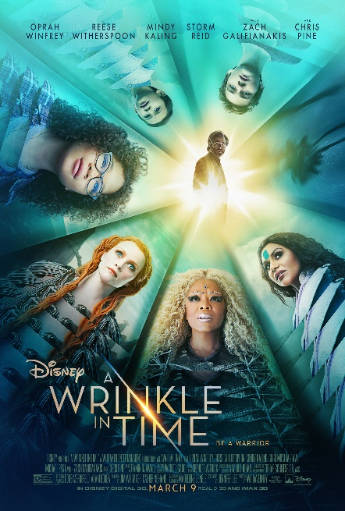
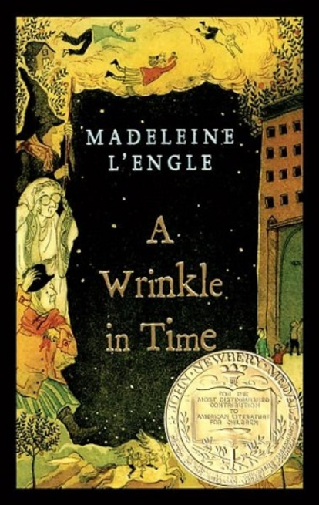
Family Field Trip Opportunity!
Meet us at the movies!!
Several of our fourth graders read Madeline L’Engle’s A Wrinkle in Time for their Newbery book report.
On Thursday, March 22, Ms. Larson, Ms. Bernardo (and her son, Mason) will be at the North Bend Theater to watch the movie at 7 pm.
All fourth graders (with siblings and friends) are welcome to attend, with parent supervision.
For more information on the movie, including parental reviews, please use the follow links:
https://www.momgenerations.com/2018/03/a-wrinkle-in-time-movie-review-parents/
https://www.commonsensemedia.org/book-reviews/a-wrinkle-in-time/user-reviews/adult
https://www.rogerebert.com/reviews/a-wrinkle-in-time-2018
Please fill out the RSVP form below, and return by Wednesday, March 21.
Hope to see you at the movies!
~ Ms. Bernardo and Ms. Larson

Yes, (name)_______________________________ will meet you there.
Parent attending: _________________________________________
Cellphone number: ________________________________________
Approximate number of people attending: ___________________

