Topic 13 – Review Answer Key
Extending Fraction Concepts
Mathematician_____________________________________________

13.1 – I can use unit fractions and multiplication to describe fractions that are multiples of the unit fractions.
Vocabulary
A unit fraction is a fraction that describes one part of the whole. Unit fractions always have a numerator of 1.

Write the fraction as a multiple of a unit fraction.

1. 2/3 = 2 x 1/3

2. 7/10 = 7 x 1/10

3. 8/8 = 8 x 1/8

4. 6/5 = 6 x 1/5

13.2– I can multiply a fraction by a whole number.

Write a multiplication equation with a whole number and a fraction for each picture.

5. 2 x 2/5 = 4/5
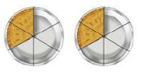
6. 5 x 1/8 = 5/8
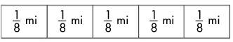

13.3– I can multiply a whole number and a fraction to solve problems.

Multiply, and write the product in simplest form.
7. 4 x 1/3 = 4/3 = 1 1/3
8. 6 x 3/8 = 18/8 = 2 2/8 = 2 1/4
9. 8 x 2/5 =16/5 = 3 1/5
10. 4 x 5/8 = 20/8 = 2 4/8 = 2 1/2
13.4– I can write fractions as decimals and decimals as fractions.

Write a decimal AND a fraction in simplest form for each part of the grid that is shaded.

11. Fraction 3/10 Decimal 0.3
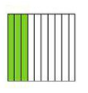
12. Fraction 5/10 Decimal 0.5
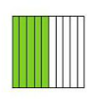
13. Fraction 88/100 Decimal 0.88
14. Fraction 60/100 Decimal 0.60
13.5– I can locate and name fractions and decimals on a number line.
15. Write the fraction and decimal that is located at Point R.
Fraction 3 2/10 = 3 1/5 Decimal 3.2
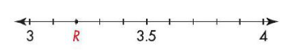
16. Write the fractions and decimals that are located at Points E and H.
Point E Fraction 6/10 Decimal 0.6
Point H Fraction 1 4/10 Decimal 1.4
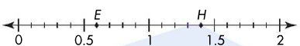
13.6– I can use equivalent fractions to write fractions and decimals.
Write each fraction as a decimal.
17. 3/12 = 0.25 18. 1/5 = 0.2
19. 3/100 = 0.03 20. 4/8 = 0.5
13.7 – I can use models and place value charts to represent decimals to hundredths. I can read and write decimals in expanded, standard, and word form.

Write the numbers in standard form.

21. six and eighteen hundredths 6.18

22. four and forty-six hundredths 4.46

23. 6 + 0.3 + 0.07 = 6.37

24. 3 + 0.01 = 3.01

Write the number in word form AND give the value of each underlined digit.

25. 2.47

Two and forty seven hundredths 7 is 7 hundredths

26. 1.85

One and eighty five hundredths 8 is 8 tenths
13.8 – I can use models and place-value charts to compare decimals to hundredths. I can use great-than and less-than symbols to order decimal numbers.

Write > , <, or = to compare each number.
27. 0.7 > 0.57
28. 0.3 = .30

Order the numbers from least to greatest.

29. 0.65, 0.6, 0.71

0.6, 0.65, 0.71

30. 0.5, 0.25, 1.05

0.25, 0.5, 1.05
13.9 - I can read, write, and compare decimals in tenths and hundredths using money.
Vocabulary
A dime is one tenth of a dollar.
A penny is one hundredth of a dollar.
A decimal point is used to separate the dollars from the tenths and hundredths of a dollar.

Write the following amounts using dollar signs and decimal points.

31. 6 dollars + 9 dimes + 3 pennies $6.93
32. 4 dollars + 7 dimes $4.70
33. 6 dollars + 8 pennies$6.08

