Name

Gravy Group OPTIONAL Homework Project:
Student produced, parent guided
Topographical Map of the State of Washington
Due: _________________________________

Steps:
- Draw the outline of the State of Washington on a piece of cardboard or sturdy surface (about 14 inches by 16 inches.)
- Use clay, play-doh, or model magic to show the elevations of Washington.
- Paint it, or color it, the appropriate colors using the guide below.
- Add labels of important places (see list on the next page).
- Using yarn, divide WA State into its five regions and clearly label or mark them

Supplies Needed:
Heavy cardboard or sturdy surface (medium pizza box?)
Clay (sample recipe below), play doh, or model magic
Paint-watercolors or tempera (if making clay)
Yarn
Black Sharpie marker

A possible clay recipe:
2 cups of flour
½ cup salt
2 tablespoons of liquid detergent
Just enough water to make moldable
Feel free to use any clay or recipe that works for you.

Color guide:
Blue---water
Green---sea level to 600 feet
Yellow---600 to 3000 feet
Orange---3000 to 10,000 feet
Red---above 10,000 feet

Important Places to label:

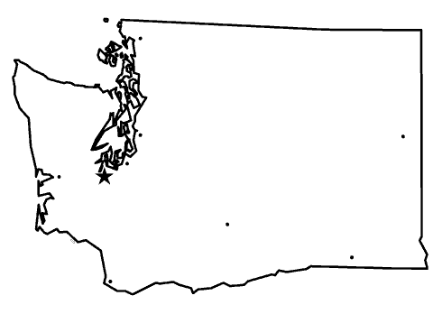
- Washington State Borders
  - Pacific Ocean
  - Canada
  - Idaho
  - Oregon
- Cities and Towns
  - Seattle
  - Tacoma
  - Olympia (capital)
  - Spokane
  - Snoqualmie
  - Yakima
- Important land and water features
  - Mt. Rainier
  - Mt. Saint Helens
  - Mt. Adams
  - Mt. Baker
  - Mt Olympus
  - Glacier Peak
  - Puget Sound
  - Columbia River
  - Snake River
- 5 Regions of Washington

- Coast
- Western Lowlands
- Cascade Mountains
- Okanogan Highlands
- Columbia Plateau

***Also include a compass rose with intermediate (medial) directions and a map key.

In the map key include:

- an elevation color guide,
- symbols for mountains,
- cities,
- and the capital.

Name ____ Date

Rubric for Topographical Map
Washington State Borders  Pacific Ocean, Canada,  Idaho, Oregon | ________out of 8
Cities and Towns  Seattle, Tacoma, Olympia  Spokane, Snoqualmie, Yakima | ________out of 12
Mountains  Mt. Rainier, Mt. St. Helens  Mt. Adams, Mt. Baker, Mt. Olympus,  Glacier Peak | ________out of 12
Water Features  Puget Sound  Columbia River  Snake River | ________out of 6
Five Regions of Wa  Coast, Western Lowlands, Cascade Mountains, Okanogan Highlands, Columbia Plateau | ________ out of 5
Compass Rose | ________out of 4
Map Key  Elevation Color Guide  Symbols for mountains, cities, and capital | ________out of 8
On time and effort | ________out of 5
Gravy
Please list
Total Score out of 60:

Ideas for More Gravy

Please remember: ALL project requirements MUST be perfect before you can add gravy.
Gravy points will not be awarded if requirements are missing.

Points of interest or tourist attractions

Additional natural features: rivers, lakes, mountain peaks

Additional cultural/human features: towns, cities, landmarks

Businesses or products specific to the regions

You are the Washington State expert…. Be creative!!

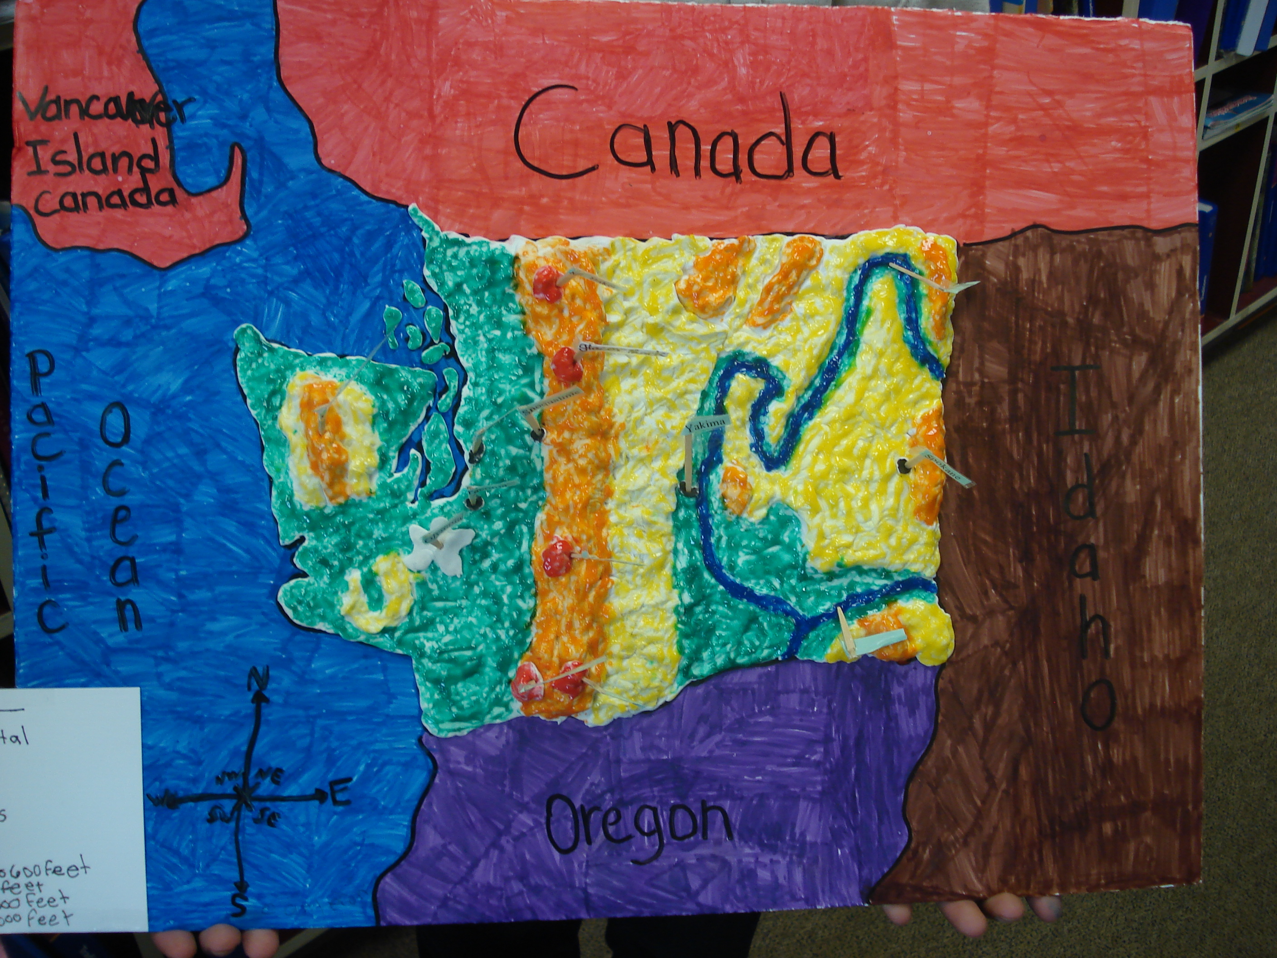 sa

