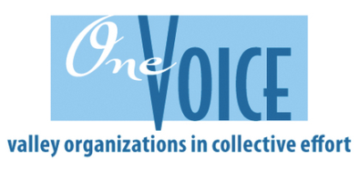
Every year, through community donations, the One Voice event provides basic necessities and small pleasures to
275 families, helping about 800 kids.

Let’s show our generous CUB spirit and
give what you can.
(See grade level giving recommendations below).

Kindergarten- Toilet paper, diapers, or baby wipes
1st Grade- Winter clothing (new or gently used): coats, gloves/mittens, hats; or dental products
2nd Grade- Non-perishable food; diapers or baby wipes
3rd Grade- Gingerbread house kits; blankets
4th Grade- Toys; toothbrushes, toothpaste, floss
5th Grade- Gift cards; non-perishable food

Items will be collected in your child’s classroom during the week of 12/03-12/10.
More info to follow at a later date.
Every year, through community donations, the One Voice event provides basic necessities and small pleasures to
275 families, helping about 800 kids.

Let’s show our generous CUB spirit and
give what you can.
(See grade level giving recommendations below).

Kindergarten- Toilet paper, diapers, or baby wipes
1st Grade- Winter clothing (new or gently used): coats, gloves/mittens, hats; or dental products
2nd Grade- Non-perishable food; diapers or baby wipes
3rd Grade- Gingerbread house kits; blankets
4th Grade- Toys; toothbrushes, toothpaste, floss
5th Grade- Gift cards; non-perishable food

Items will be collected in your child’s classroom during the week of 12/03-12/10.
More info to follow at a later date.

