Fourth Grade Family Field Trip suggestions:

We are fortunate to have two wonderful museums close by that complement our Social Studies curriculum. I hope you will consider taking a family field trip or gathering a few friends together for a special afternoon/evening of learning.

The first Thursday of every month is FREE and the museum is open late!!
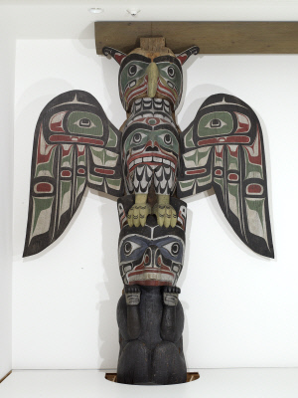

The Seattle Art Museum has an amazing collection of Northwest Coast Native American artifacts.

I will be upstairs in the Native American Collection Rooms at SAM from 5:30 – 6:30 pm this week on Thursday, January 7.

Won’t you bring some 4th graders to the museum and we can all enjoy it together? I’d love to see you there!

Also, The Burke Museum on the University of Washington campus has a wonderful display of artifacts downstairs.
http://www.burkemuseum.org/exhibits/browse/pacific_voices

______ Yes! We can make it on Thursday, 1/7. See you at SAM! My cell phone # is _______________

______ Darn! Sorry, we can’t make it for the family field trip.

Student Name: _______________________________________________________________________

Name of Parent Attending: _____________________________________________________________

Return to school so Ms. Bernardo knows who to be on the lookout for this week at SAM.

