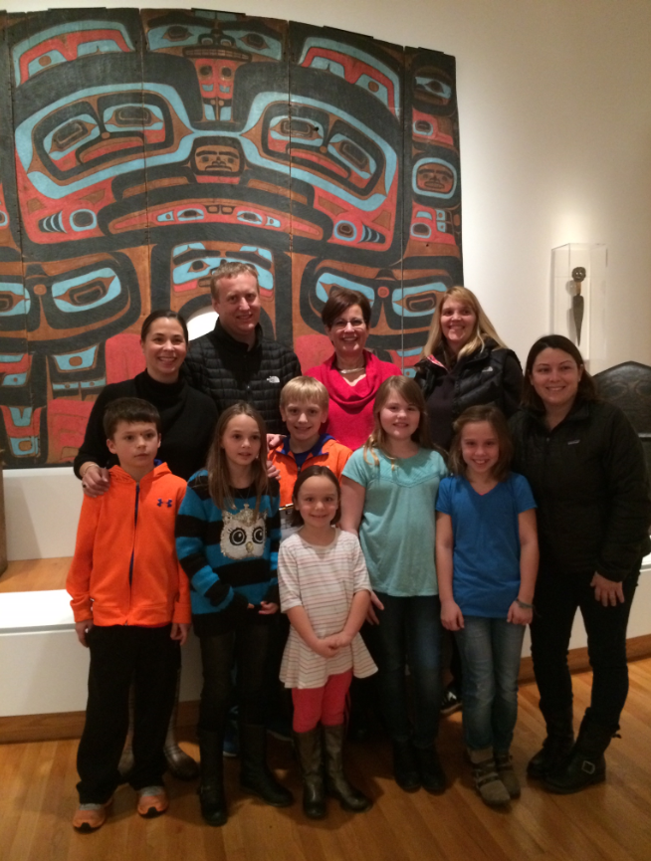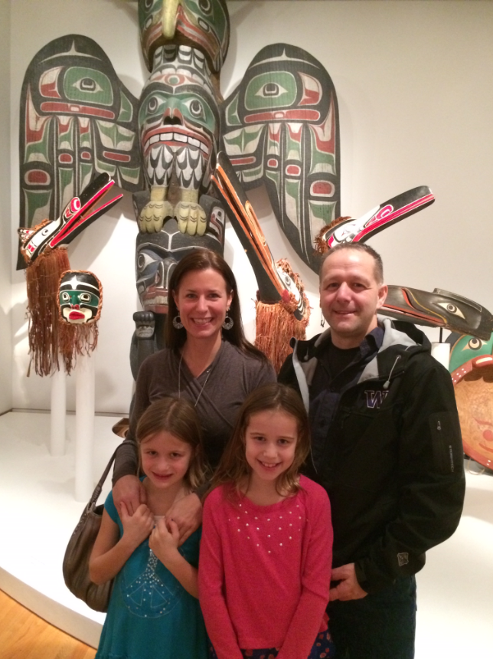
- Family Field Trip suggestions:

We are fortunate to have two wonderful museums close by that complement our current Social Studies curriculum. Please consider taking a family field trip or gathering a few friends together for a special afternoon/evening of learning.
The first Thursday of every month is FREE at the Seattle Art Museum!!
The Seattle Art Museum has an amazing collection of Northwest Coast Native American artifacts.
Some of the 4th grade teachers will be in that exhibit room at SAM
from 5:30 – 6:30 pm on Thursday, February 1.

Won’t you bring some 4th graders to the museum and we can all enjoy it together?
All 4th graders are welcome with a parent chaperone! Please RSVP!

Yes!!! We can come!!

Student name: _____________________________________________________________
Adult chaperone: ___________________________________________________________
Cell phone: ________________________________________________________________
Also bringing these 4th graders: _______________________________________________

