Name ___________________ Date ___________ Number _____
4th Grade Science Fair Project
It’s time to talk s-c-i-e-n-c-e! As stated in our Washington State K-12 Science Standards, “Science is an active process that involves thinking in systems, asking and answering questions through investigations, and applying science and technology to solve real-world problems.” So, what better way to learn about science than to “do” it?” Students have selected a project from http://www.sciencebuddies.org/, their own imagination, or another source, and should share this information with you. This project requires parental approval. Once you have reviewed the “Materials and Equipment” and “Experimental Procedure” sections of the project so that you are aware of the commitment involved, please sign below. If you have any questions or concerns regarding this project, feel free to contact me!
*********Parent Signature __________________________________________***********
Please use the Guidelines for Time Management listed below. Your student will be required to complete sections of this packet by the due dates assigned in the guidelines. You will need to purchase a Tri-fold Poster board (please let me know if your family needs help with this – donations of extra tri-folds are appreciated!) and the experiment is expected to be completed at home. However, the typing and assembly of project board will be completed in class.
The most important thing for your student to remember is that this is their project, and 4th grade hands should do the work. However parents and teachers are there to give them support and help along the way. Your support is greatly appreciated.
Due Date | Section Assignment
Wednesday, February 28 | Parent Signature & Title
Friday, March 2 | Question & Purpose  Hypothesis  Diagram & Variables  Procedure (planned)
Monday, March 5 | Experiment Complete
Tuesday, March 6 | Procedure (final) & Data  Bring tri-fold labeled with your name  (Trifold donations appreciated!)
Wednesday, March 7 | Conclusion
Thursday, March 8 | Assembly of Display Boards in Class
Tuesday, March 13 | Classroom Science Fair
Thursday, March 15 (optional) | CVES Science Fair
**Keep in mind your student’s project may also be entered in the 2018 Washington State Science & Engineering Fair held on  Friday & Saturday, March 23rd & 24th in Bremerton, WA** | For more information, please visit www.wssef.org  *Deadline for General Registration is March 16th  http://wssef.org/registrationmap/

Title
Your title should be something catchy that has to do with your project. For example: if you are doing a project on electricity, your title could be “Making Sparks, “or if it is on batteries, it could be “All Powered Up.”
Please write your title below. Remember all words are important in a title, so don’t forget your capitals.
__________________________________________________________________________________________________________________________________________________________

Question
This is where you should ask, “What do I want to know?” and will help you when writing your purpose.
Example Question (written in the form of a question):
Which color do babies prefer most?
Write your question below. We will type this in class.
__________________________________________________________________________________________________________________________________________________________

Purpose
This is the “who cares?” section. In other words, why are you doing this project? What are you trying to find out? Why might this project be interesting to you or others?
Example Purpose (written in the form of a statement):
The purpose of this experiment was to find out which color babies prefer. The information from this experiment might be helpful for people who design toys and clothes for babies.
Write the purpose of your experiment below. We will type this in class.
The purpose of this experiment ______________________________________. The information from this experiment might be helpful for__________________
_________________________________________________________________________.
Before you write your hypothesis, read the Abstract, Objective, Introduction, and the Experimental Procedure for your project. Also, review the Terms and Concepts and Questions so that you can fully understand your project. You will more than likely need your parents or a teacher to help you with this as I am certain you will come across a few words that are unfamiliar/challenging.
Hypothesis
The hypothesis is an educated guess that tries to answer a question or solve a problem that you are trying to find out more about. The hypothesis is done after you do your research about the topic and before you do any experimenting. Remember: If you already know the answer, you shouldn’t be doing this project! Your hypothesis is an “I think ….because….” statement.
Example of a Hypothesis
I think babies will prefer the color blue because my little sister has all blue toys and really likes to play with them.
Write your hypothesis below. We will type this in class.
I think _______________________________ because ______________________
__________________________________________________________________.
Materials
For this section, you need to list out what you used in your experiment (this should be the same list as the one found in the “Materials and Equipment” section of your project). The more specific you are the better? Don’t just write “plants, write “Three string bean plants.” Also, don’t forget to include measurements. Rather than listing “milk,” list “1/2 cup milk.” You can think of this section as a recipe that someone else can follow if he/she wants to do your experiment too.
Example of a Material list:
Bad Material List | Good Material List
- Water  - Watch  - Ruler  - Dirt | - 20 Liters of Water  - Stop watch with second hand  - Metric ruler with millimeters listed  - 3 cubic meters of potting soil

Please complete the material list below. We will type these in class.

Material List

Diagram
A diagram of the investigation set-up with labeled variables, amounts, times, #s of etc. can be as simple as a stick figure drawing or as sophisticated as actual photos. You must include a description of the variables.
- Controlled Variable: things that are kept the same to make the test fair. If they were not the same the test could be influenced.
- Manipulated Variable: the one thing that was changed on purpose used for comparison during the investigation.
- Responding Variable: the data that is being recorded, or what you are finding
Sample Variables
Controlled  - Same size pieces of colored paper  - Same high chair to hold baby | Manipulated  - Color of paper | Responding  - Time the baby looks at the paper
Please complete the chart below.
Controlled | Manipulated | Responding

Procedure
In this section, you will list out everything you do in your experiment. Yes, everything! Another person should be able to do exactly what you did, step by step. Make sure that you write it as though you’re telling someone else how to do the experiment. For example, don’t write, “I added 2 teaspoons of salt to the water.” Instead, write, “Add 2 teaspoons of salt to the water.” Again, think of it like a recipe.

Sample Procedure
- Put baby in high chair
- Hold up one piece of construction paper
- Time how long the baby looks at it, and record time in log
- Repeat for all five colors
- Repeat steps 1-4 for remaining babies

Please list out the steps/procedure in your experiment below. We will type and print them in class.

Data
This section should include any tables, other data, or pictures that you drew or took while conducting the experiment. If you are using pictures, you need to make sure to include a caption explaining what each picture shows.

Examples of Data
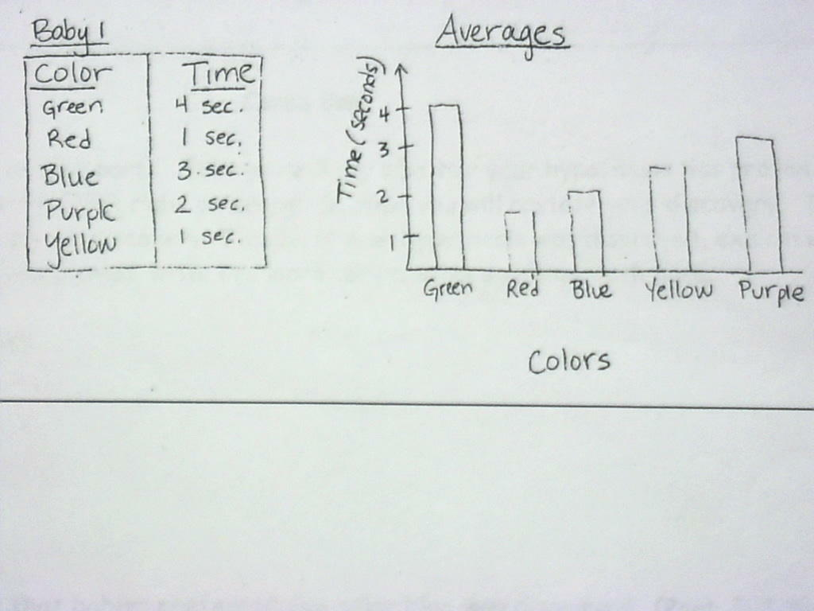

Please include your data in the space provided below or attach it to this packet. You may neatly hand write/draw this data or you may want to use Google Sheets, Excel, or any other computer program that provides a digital illustration of the data you collected. This is entirely up to you!

Conclusion
Your conclusion should have three parts. First, you will say whether your hypothesis was proven or disproven. Your results are NEVER right or wrong!! Second, you will restate your discovery. Third, you will use data to back up your discovery (think of this like a supporting detail).

1-proven/disproved
2-discovery
3-proof that supports your discovery

Sample Conclusion
(Part 1) My hypothesis that babies preferred the color blue was disproven. (Part 2) I found out that babies prefer green. (Part 3) Babies looked at the green paper the longest, 4 seconds!

Please complete the conclusion below. We will be typing this in class.

Conclusion
(Part 1) My hypothesis _________________________________________
was proven/disproven. (Part 2) I found ____________________________
___________________________________. (Part 3—write a supporting detail to your second part) ______________________________________
_____________________________________________________________.

Display Board
Your display board is where you get to show off your experiment and what you learned! This will be completed at school. Remember to think about the order in which you did your project when planning out how to arrange your board; don’t paste the results on your board first before the hypothesis. Also, consider what will make your display attractive! Here are some ideas that might help: use colored mats behind your report sections to make them stand out; add photographs or illustrations of your experiment; enlarge your data tables and/or graphs so they are easier to read. Remember that lots of people (in our class or at the Science Fair) will be looking at what you did, so make it something you will be proud of!

AS AN EXTENSION, not a requirement, you may include:
Discussion
In this section, use what you discovered to answer questions like the following or others you may have.
- Apply what was discovered to make predictions about real world situations.
- Take away part of the system or change something in the system and predict what would happen and use your data to support your answer.
- Design a new investigation that is similar but with a different manipulated variable
- Discuss why or why not your reasoning was proven or disproven
- Discuss experimental design flaws and changes that could be made
Sample Discussion
In my experiment, one design flaw might have been that I showed all the babies the green paper first. By the time I got to the blue, they might not have been interested anymore. If I were to do the experiment again, I would make sure I changed the order in which I showed the colors. Next, if I were to do a different experiment, I would want to find out whether babies prefer their toys to be all one color or many different colors!

Example of a Tri-fold Poster board

